Format Setting(USB) Instruction
Step 1 Connect with computer through USB interface directly. When the buzzer sounded, reader into the self-inspection. And the same time, LED turn into red means standby.
Step 2 Open the soft ,Reader is working after a beep. As the picture:
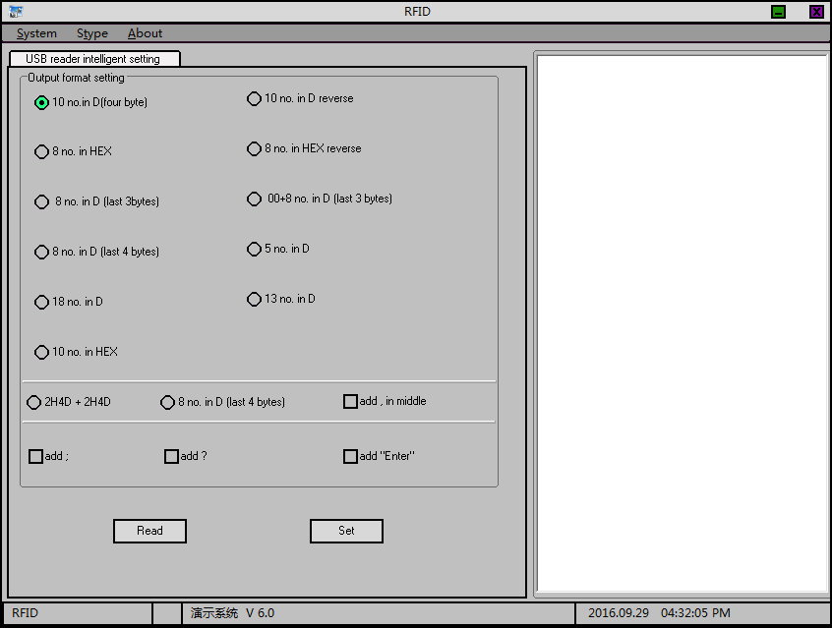
Step 3, Select a format you want and click the tab , then put a card on the reader, read the card successfully after a beep and the data displayed in the right area. As follow:
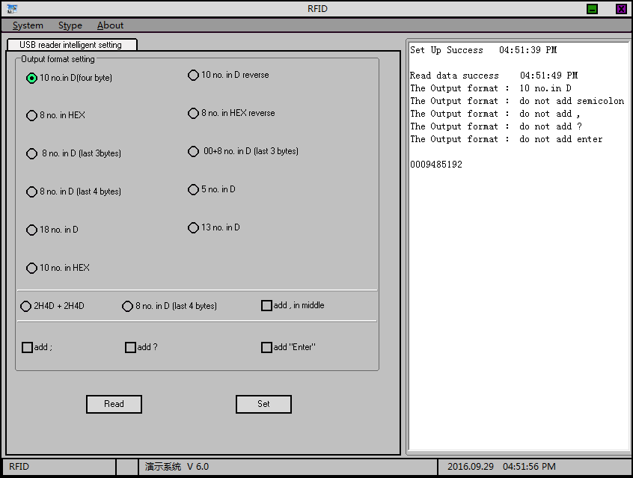
Example for format
Format | Card Number | Format | Card Number
10 no.in D(four byte) | 0009485192 | 10 no. in D reverse | 2293993472
8 no. in HEX | 0090bb88 | 10 no. in D reverse | 88bb0900
8 no. in D(last 3bytes) | 09485192 | 00+8 no. in D(last 3bytes) | 0009485192
8 no.in D(last 4bytes) | 09485192 | 5 no. in D | 48008
18 no. in D | 000948519214448008 | 13 no. in D | 0352196803464
10 no. in HEX | 520090bb88 | “10 no.in D(four byte)”+“add ?” | 0009485192?
